Report #3 (part2)  
 validate the script about the surface reaction mechanism over Nickel catalyst

# Add the gas-phase reaction for the mechanism file

From your advices, and after finding out the information on Internet, I realized that the mechanism file <<gri30.cti>> contains the reaction steps for the total oxidation of methane. So, I added some species from <<gri30>> into our mechanism.

To validate this total oxidation reaction, I found out also a reference [1] for it (Fig.1) with the reacting conditions in the Table 1.

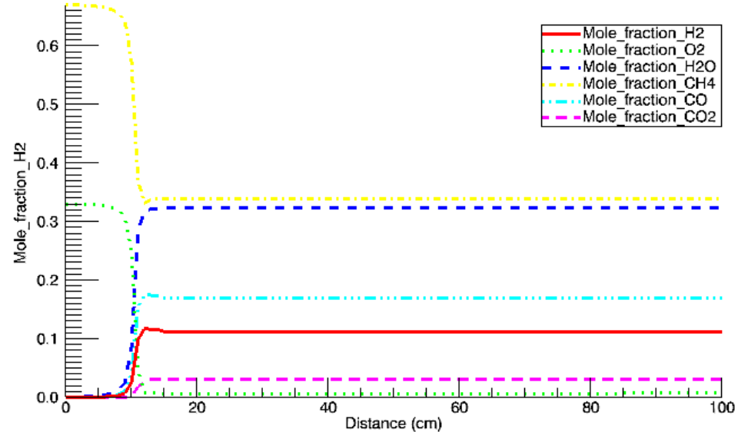

Figure The Mole Fraction of species of the reference [1]

|  |  |
| --- | --- |
| Stoichiometric |  |
| Type of reactor | Isothermal Reactor |
| Length |  |
| Diameter |  |
| T, P |  |
| Velocity of flow |  |

Table The reacting condition of the methane total oxidation reactor [1]

First of all, I use an available code <<prf.py>> to check it (Fig.2) and then I used our code – Chain of Reactors (Fig.3) with two parameters: porosity = 1, and active surface area per unit volume = 0 and another parameters in the table 1. All of results are correct, and close with the reference. It means that our mechanism had the methane total oxidation reaction.

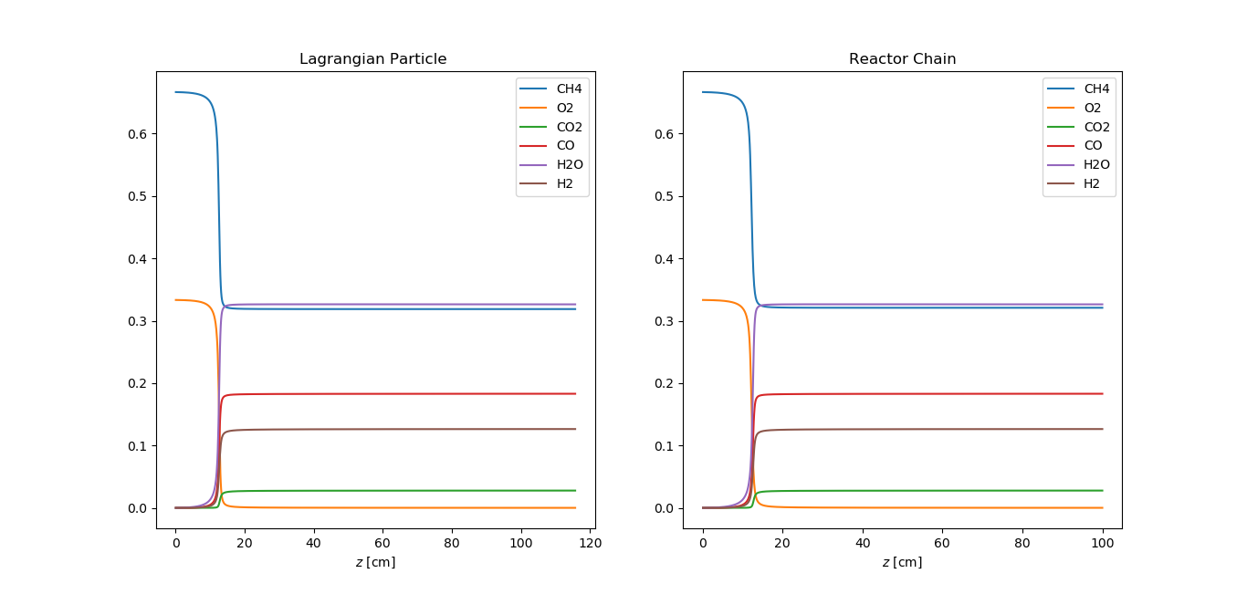

Figure The result of code

# Validate the mechanism file

Karla Herrera Delgado *et al.* [2] set up the experiment about **dry reforming of methane**, **stream reforming of methane**, and **partial oxidation of methane** in a fixed-bed reactor as depicted in Fig.1

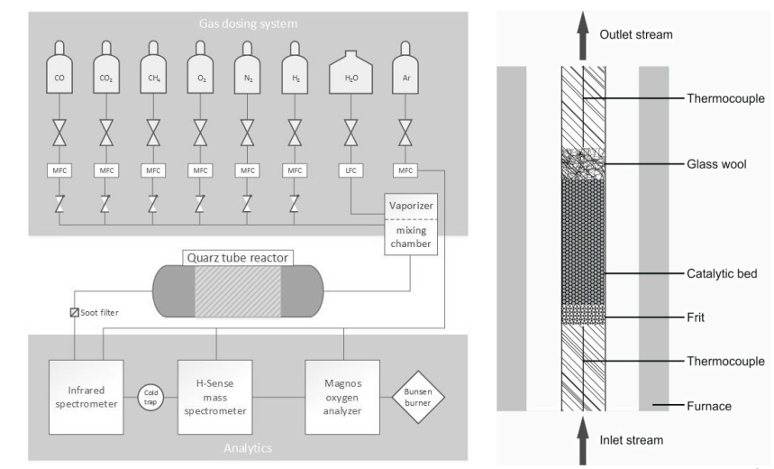

Figure Schematic diagram of the experimental setup used for catalytic reforming experiments over a nickel bed catalyst [1]

The reactor is a quartz tube with inner diameter of 100 mm filled with 20mg of nickel-based catalyst with a reaction zone of 27 mm length. The reactor will be conducted at isothermal condition. The Nickel catalyst bed has porosity and Active catalytic area to volume ratio (Table 1).

|  |  |
| --- | --- |
| Inner diameter of reactor |  |
| Length of reaction zone |  |
| Porosity |  |
| Active catalytic area to volume ratio |  |

Table Summary the parameter of experiment

New: The total flow rate used for all experiments is always 4 slpm (standard liters per minute, T = 298.15 K and p = 1 atm). This initial condition of flow rate affects to the mass flow rate of system. So, I changed the code by taking the mass flow rate before set the temperature, and pressure for each studying case and keep the mass flow rate is constant. This thing make the simulating results get more exact.

## 2.1. Dry Reforming of Methane (DRM)

The total volume flow rate of gas mixture is at , the mole fraction of each inlet species is in table 2

|  |  |
| --- | --- |
| Species | Volume percent (%) |
| N2 | 96 % |
| CH4 | 2 % |
| CO2 | 2 % |

Table Gas mixture

They investigated the concentration (%) of reactants and products as a function of temperature. From their result (Fig.10 of reference) and our script, we have the comparisons.

*Caption about result of reference: *experimentally determined (symbols); numerically predicted (lines); dashed lines = equilibrium composition at given temperature*

*Our script has the same result of numerical predict of reference about the Dry Reforming of Methane

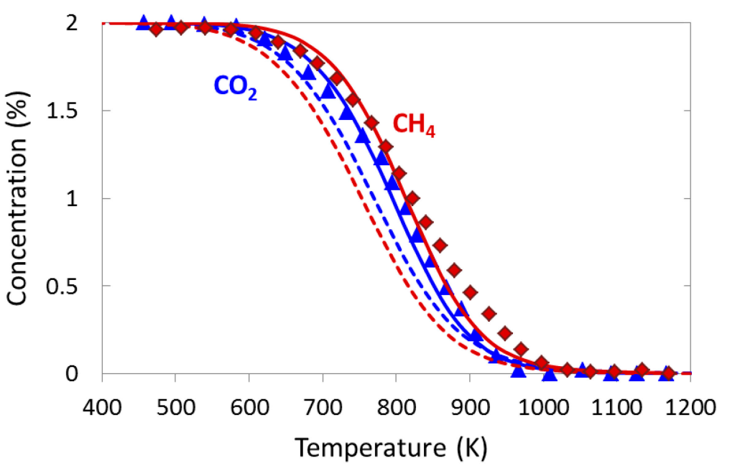

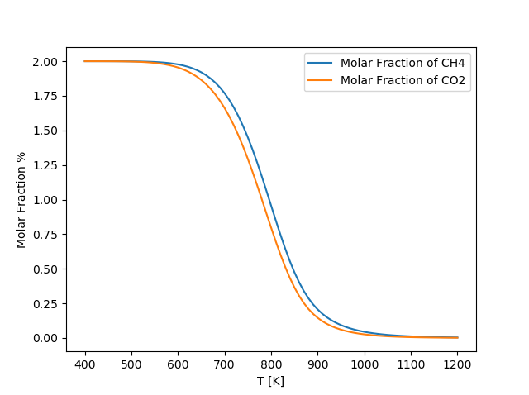

**BEFORE**

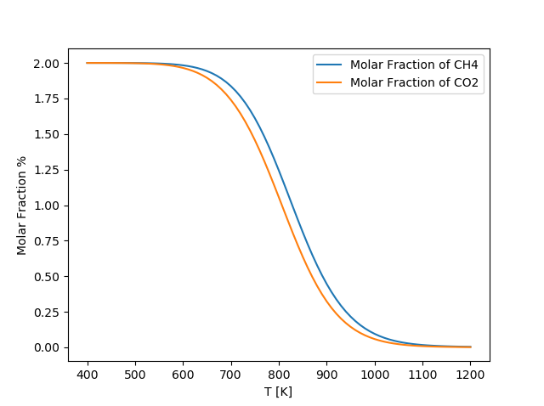

**AFTER**

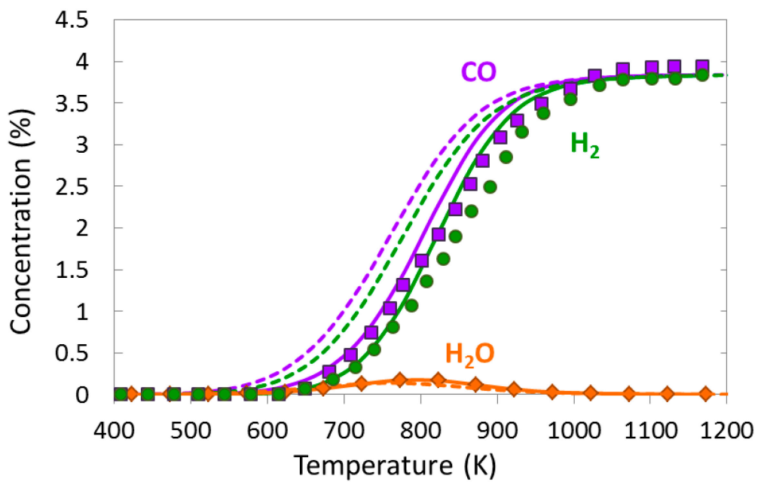

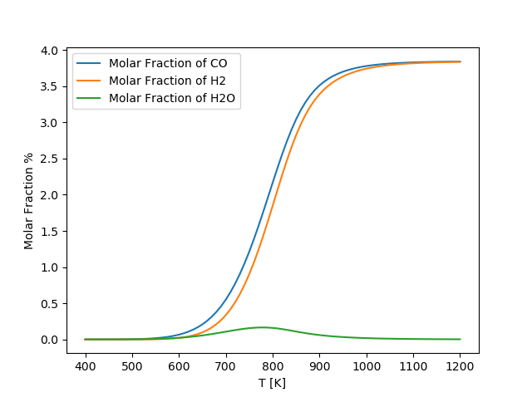

**BEFORE**

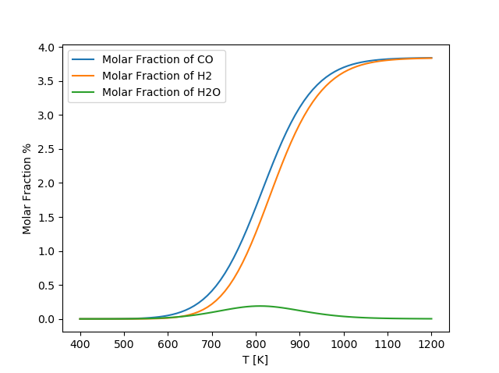

**AFTER**

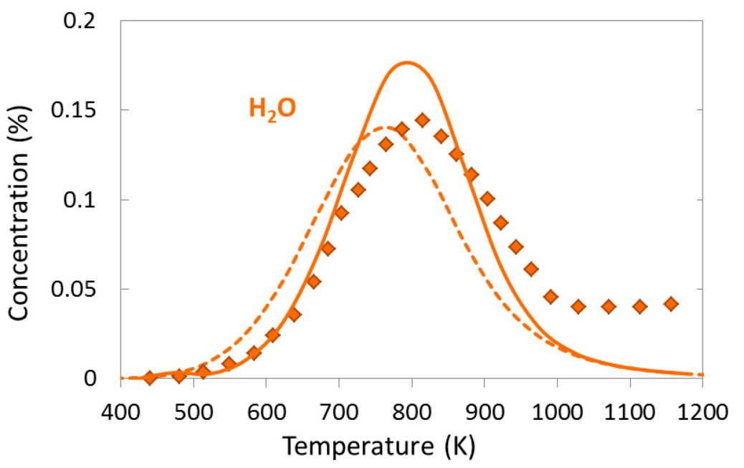

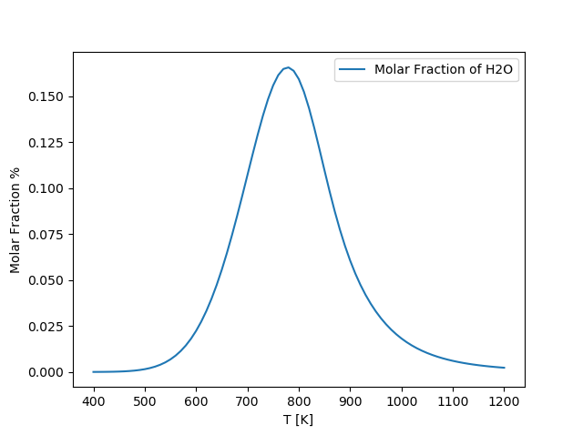

**BEFORE**

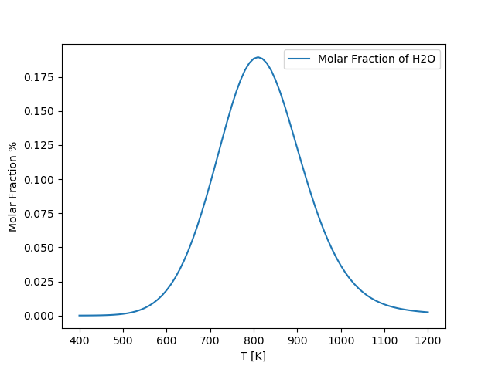

**AFTER**

## 2.2. Stream Reforming of Methane (SR)

The total volume flow rate of gas mixture is at , the mole fraction of each inlet species is in table 3

|  |  |
| --- | --- |
| Species | Volume percent (%) |
| N2 | 96,4 % |
| CH4 | 1,6 % |
| H2O | 2 % |

Table Gas mixture

They investigated the concentration (%) of reactants and products as a function of temperature. From their result (Fig.7 of reference) and our script, we have the comparisons.

*Caption about result of reference: *experimentally determined (symbols); numerically predicted (lines); dashed lines = equilibrium composition at given temperature*

*Our script also has the same numerical results of reference !

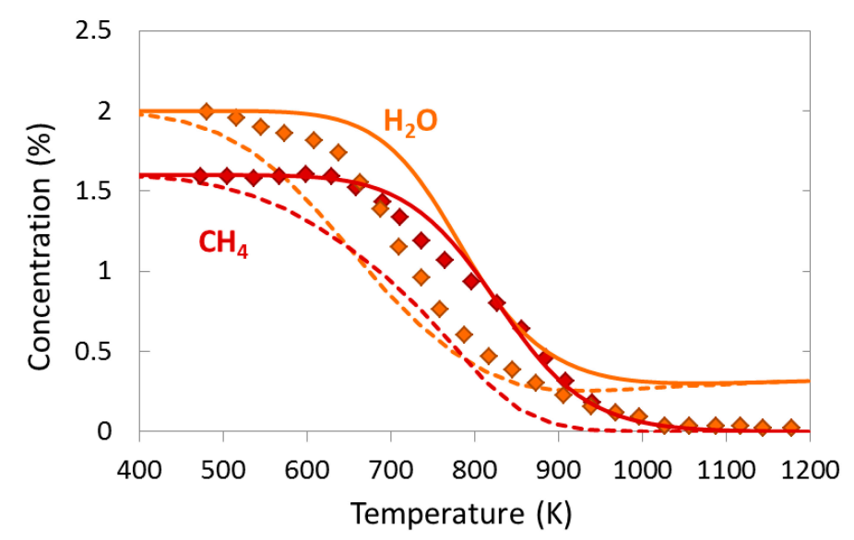

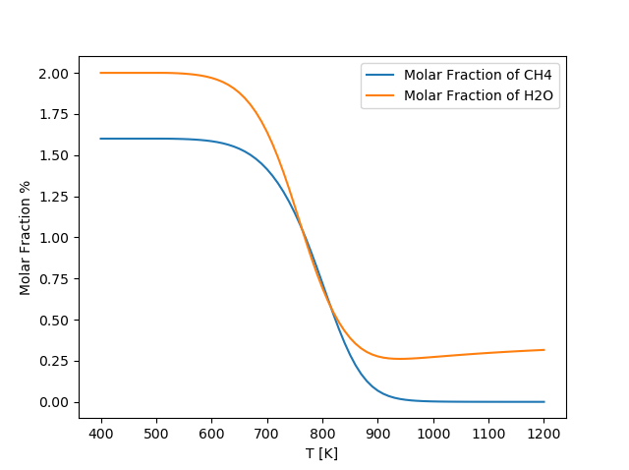

**BEFORE**

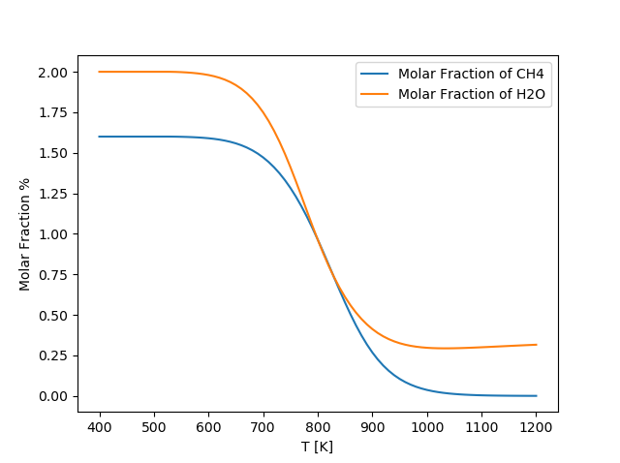

**AFTER**

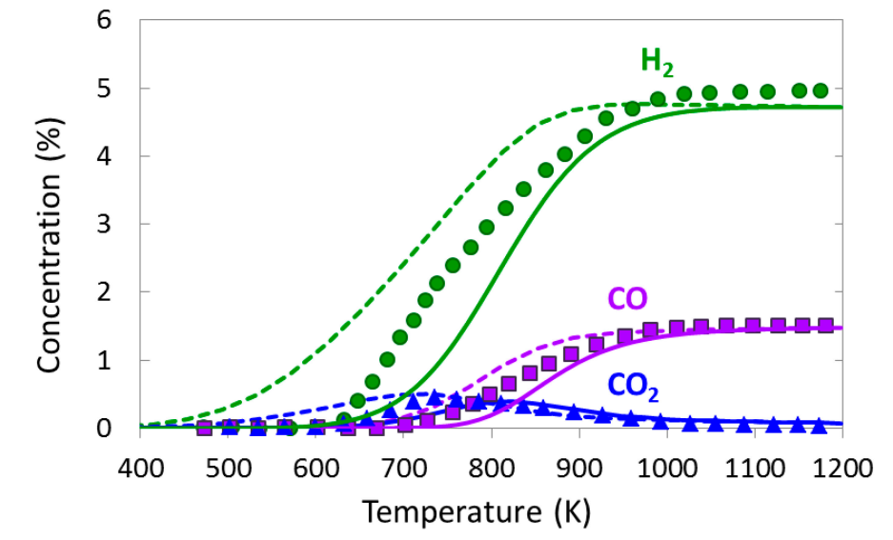

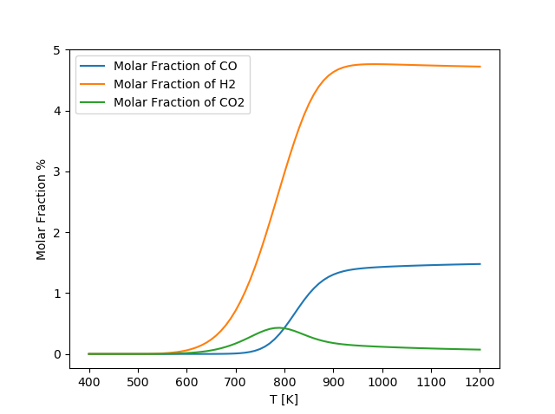

**BEFORE**

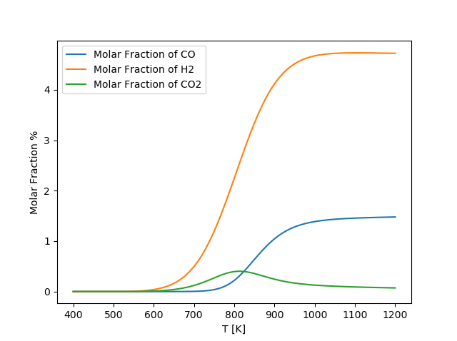

**AFTER**

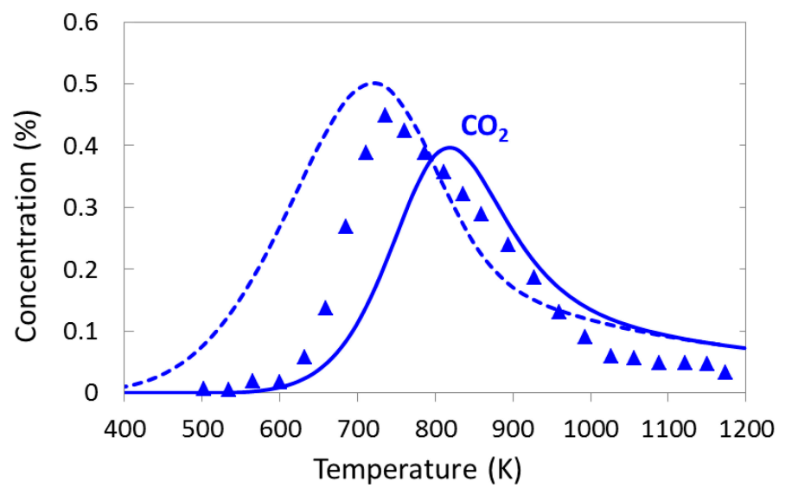

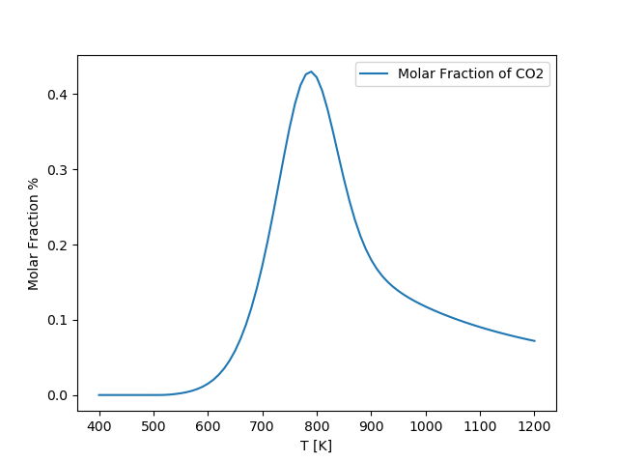

**BEFORE**

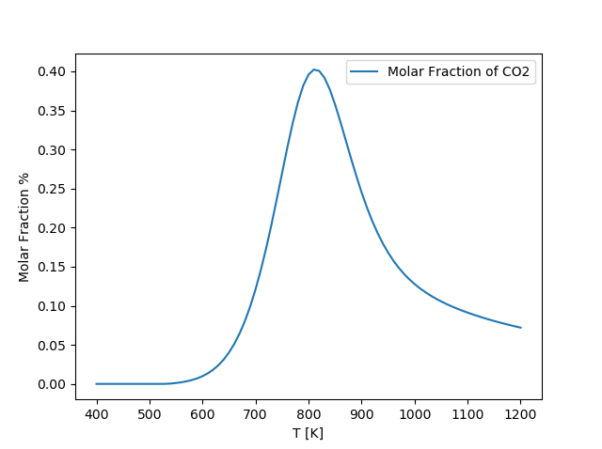

**AFTER**

Figure Comparison our script with the numerical results of reference

## 2.3. Methane Catalytic Partial Oxidation (CPOX)

There are two mechanisms to explain this case. Firstly, The direct oxidation mechanism where H2 is directly originated from methane decomposition. Secondly, The indirect route where methane is totally oxidized to CO2 and H2O, as long as oxygen is present close to catalyst surface, and then the remaining CH4 is reformed with stream or CO2 to H2 and CO [1].

The total volume flow rate of gas mixture is at , the mole fraction of each inlet species is in table 4

|  |  |
| --- | --- |
| Species | Volume percent (%) |
| N2 | 97,86 % |
| CH4 | 1,33 % |
| O2 | 0,81 % |

Table Gas mixture

They investigated the concentration (%) of reactants and products as a function of temperature. From their result (Fig. 3 and Fig. 4 of reference) and our script, we have the comparisons.

*Caption about result of reference: *experimentally determined (symbols); numerically predicted (lines); dashed lines = equilibrium composition at given temperature*

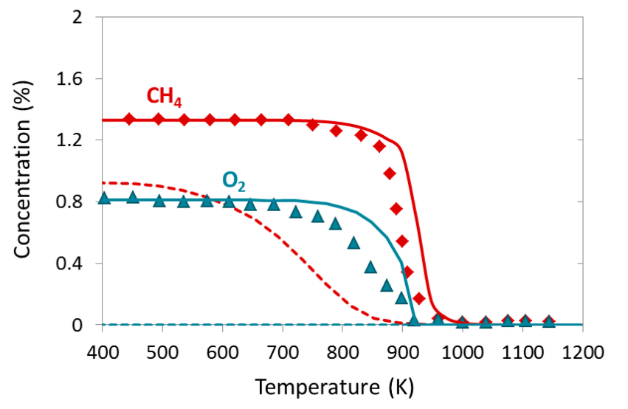

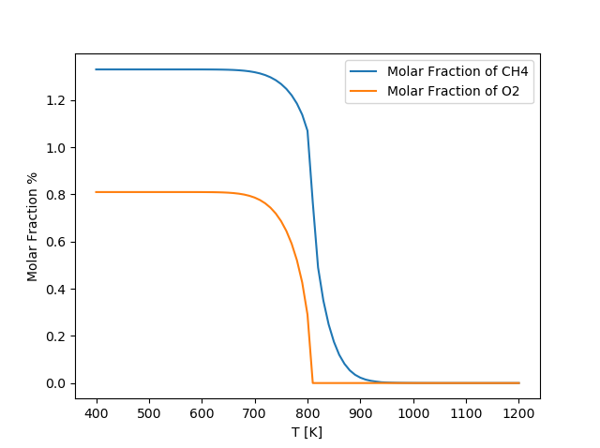

**BEFORE**

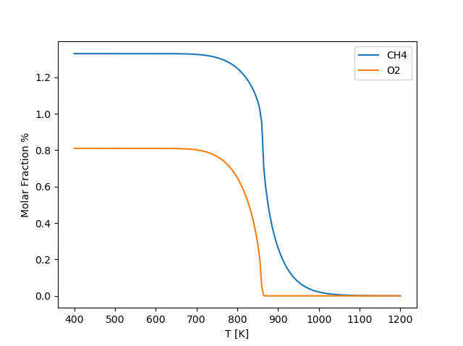

**AFTER**

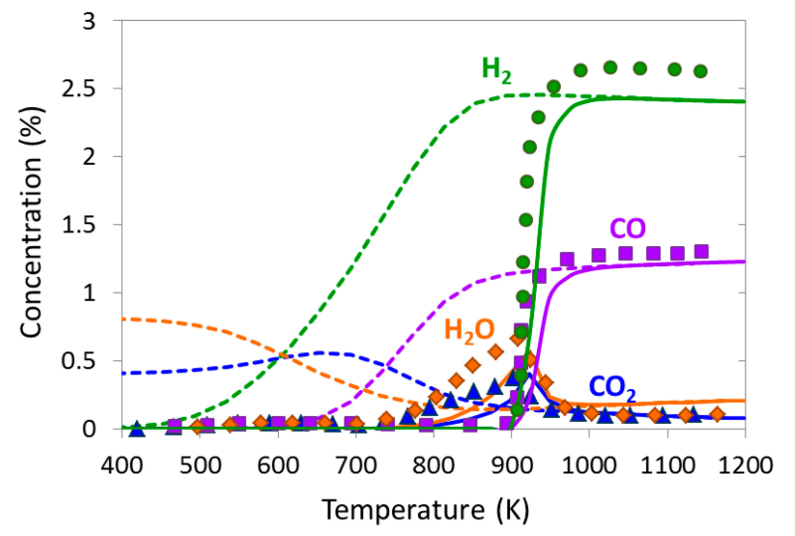

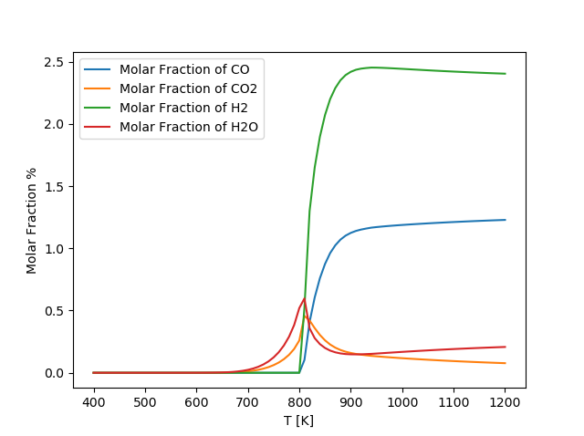

**BEFORE**

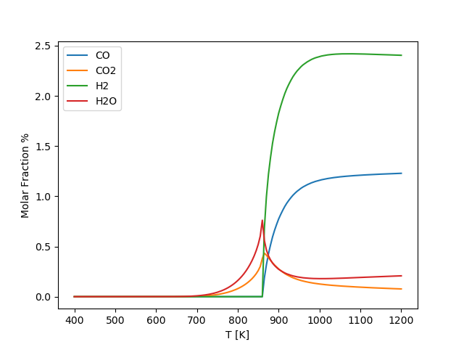

**AFTER**

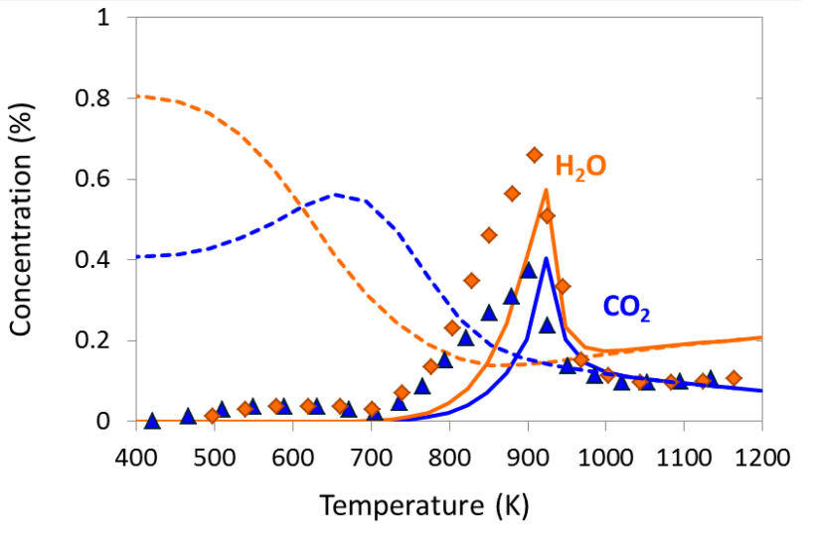

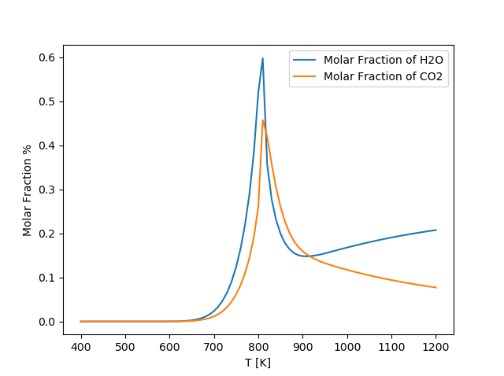

**BEFORE**

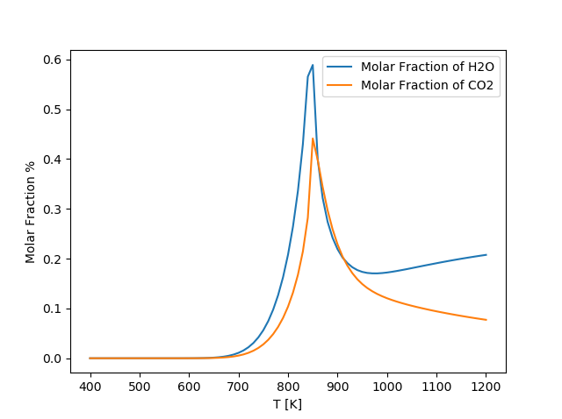

**AFTER**

Figure The concentration as a function of temperature.

NEW: The plot about the concentration as a function temperature of our script is shifted to left approximately in comparison with the reference. This is more exact than before .

They also investigated the concentration of gas-phase species and absorbed species along the catalytic bed at 973 K. This temperature means the mixture of CH4 and O2 were burn total (total oxidation) at a point along the catalytic bed, and then the dry and stream reforming of methane will occur.

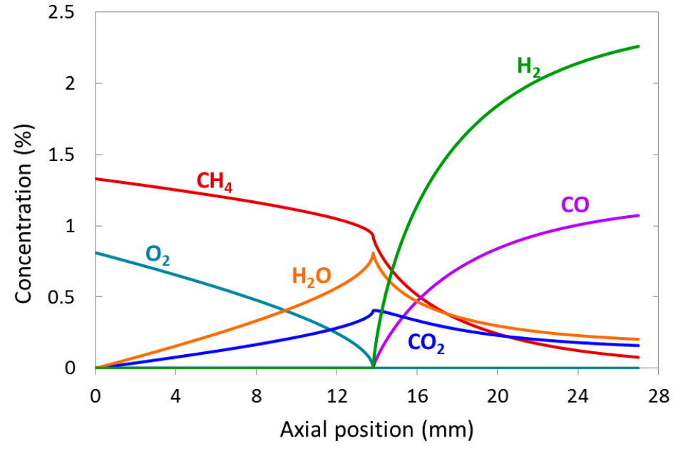

Total Oxidation of Methane

Stream and Dry reforming of Methane

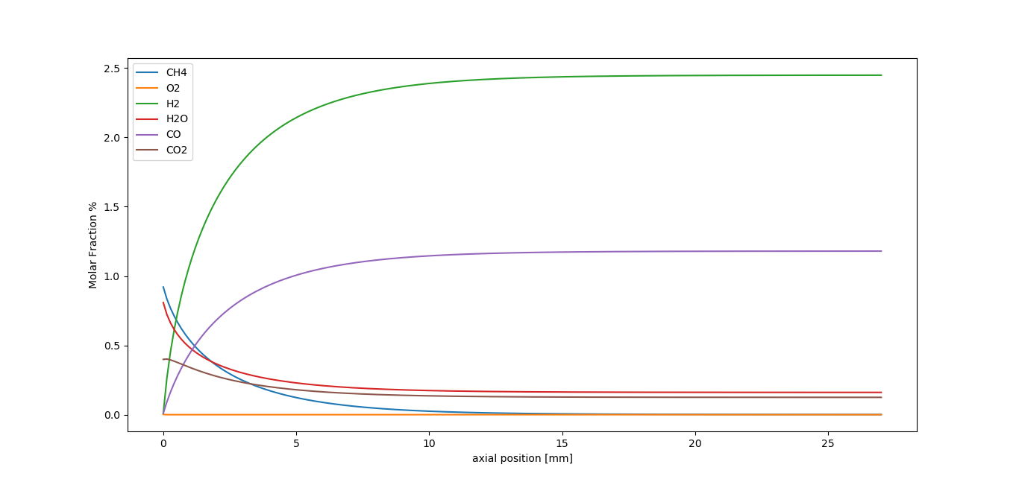

**BEFORE**

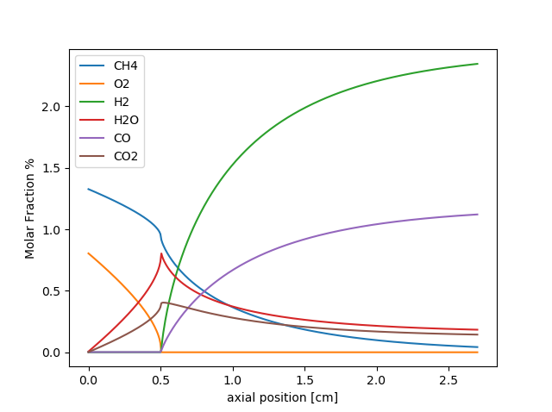

**AFTER**

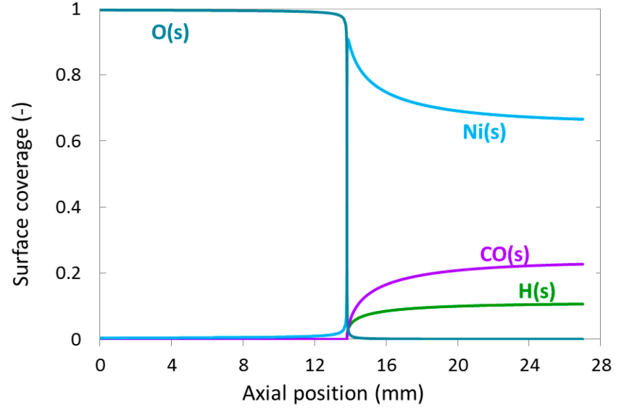

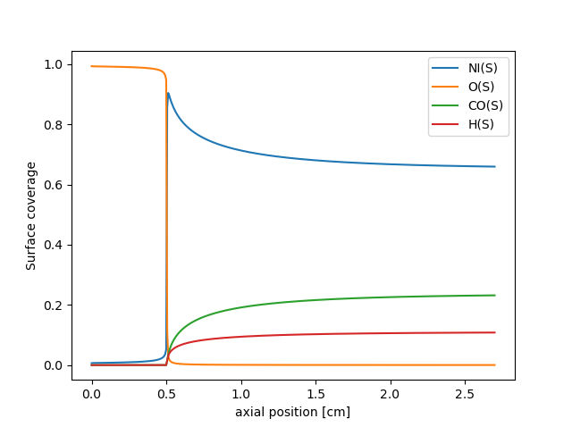

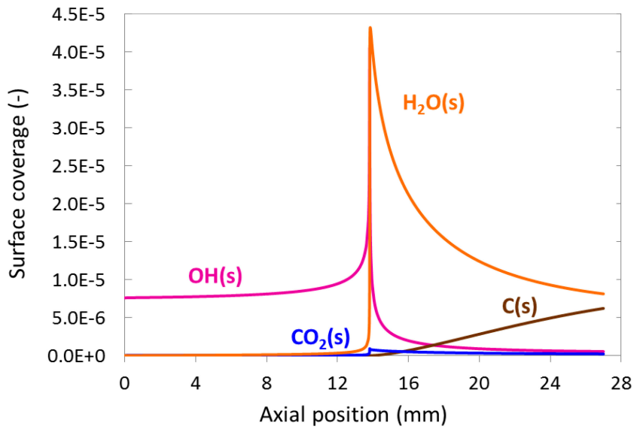

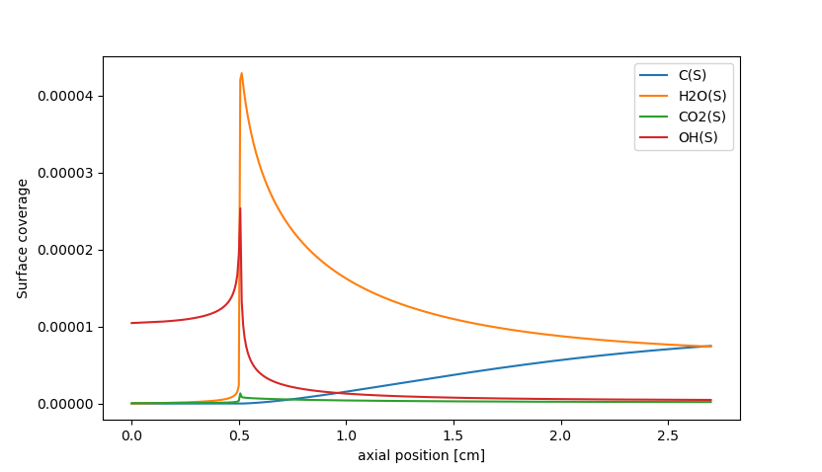

Figure Concentration as a function of position at temperature 973 K

NEW: The result about ***molar fraction vs axial position*** is also different from the reference. The transition point is at 5 mm which is shorter than the reference (at 14 mm). This difference may be affected by the initial molar fraction of absorbed species over catalyst. Because, “*before all experiments, the powdered nickel-based catalyst was conditioned with 20 vol.% O2 diluted in nitrogen at 673 K for 30 min and then reduced with 10 vol.% H2 diluted in nitrogen with a total flow of 4 slpm at 873 K, over 60 min; then the reactor was cooled down to 373 K*”*.* [2]. This thing will change initial molar fraction of absorbed species over catalyst like: NI(S) , O(S), H(S).

About our file, I declared the initial value for surface is: ‘NI(S)’ for all tests. So, I have changed these value: 'O(S):1, NI(S):1, H(S):1' and it works ! The new transition point is 6mm, but I’m not sure for this idea !

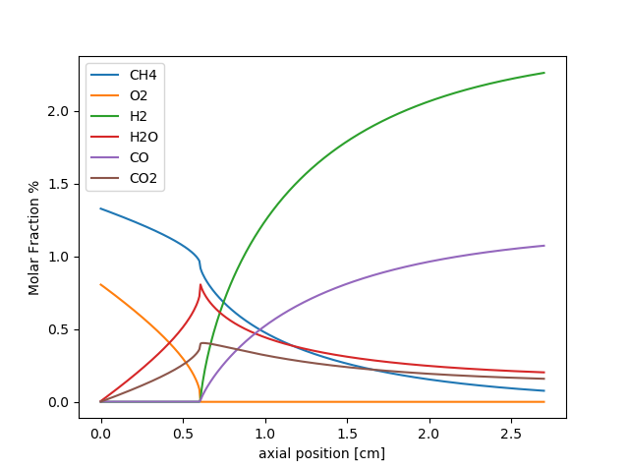

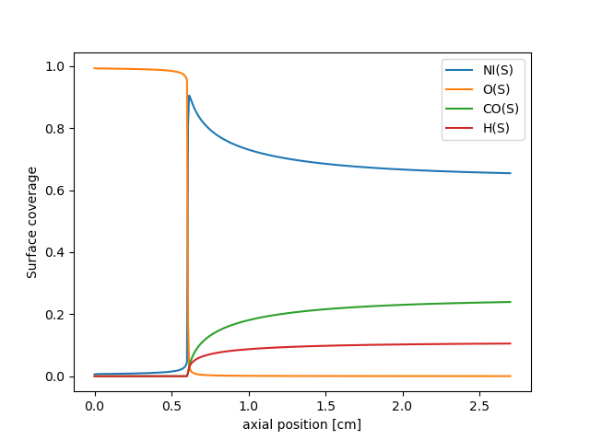

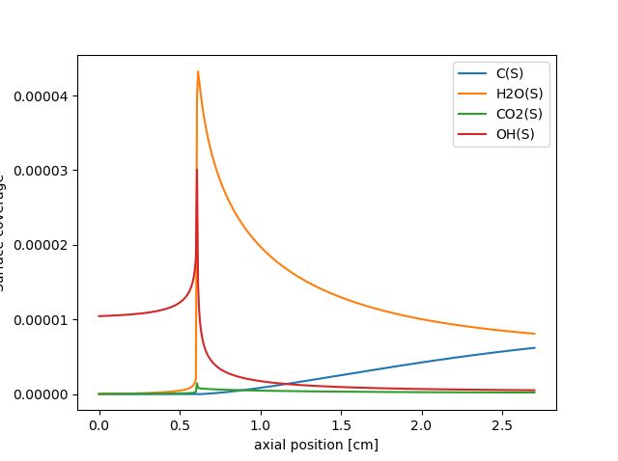

Figure The new result with new initial value of absorbed   
'O(S):1, NI(S):1, H(S):1'

# Lagrangian Particle Simulation

Similarly, I have written a program using Lagrangian Particle Simulation for the Catalytic Partial Oxidation of Methane (CPOX) <<Lagrangian_2.py>> which uses an equivalent PFR reactor (equivalent section area = section area porosity; the same length) with the surface reaction and keep a constant mass flow rate.

T = 973 # studying temperature  
t0 = 298.15 # initial temperature of gas mixture  
P = 0.986923267* ct.one_atm # studying pressure 1 bar  
l = 27 * mm # length of reactor  
d = 10 * mm # diameter of reactor  
A = np.pi * d**2 / 4  
Spv = 9.85e6 # surface area per unit volume  
Q = 200/3 * cm**3 # flow rate of volume 4 litter per minute  
e = 0.42 # porosity  
  
A_eq = A*e # equivalent area

N = 400 # Number of step

composition = 'CH4:1.33, O2:0.81, N2:97.86'

phase_cat = 'Ni_surf' # Phase of catalyst

gas1 = ct.Solution(file,'gas')  
gas1.TPX = t0,ct.one_atm,composition # initial conditions for calculate the mass flow rate

m_dot = Q*gas1.density_mass

Then I create an ideal gas constant pressure reactor, and a surface reactor.

gas1.TPX = T,P,composition  
sur1 = ct.Interface(file,phase_cat,[gas1])  
sur1.TP = T,P  
  
r1 = ct.IdealGasConstPressureReactor(gas1,energy = 'off')  
r1.volume = A_eq * l # reacting volume

rsur1 = ct.ReactorSurface(sur1,r1, A = l * A_eq * Spv)  
sim1 = ct.ReactorNet([r1])

After that, I Estimate the residence time and declare the storing variables.

t_total1 = l * A_eq / Q # Estimate the residence time

dt = t_total1 / N  
t1 = (np.arange(N) + 1) * dt  
z1 = np.zeros_like(t1)  
u1 = np.zeros_like(t1)  
state1 = ct.SolutionArray(r1.thermo)

Finally, A integrator is declared.

for n1, t_i in enumerate(t1):  
 # perform time integration  
 sim1.advance(t_i)  
 # compute velocity and transform into space  
 u1[n1] = m_dot / A_eq / r1.thermo.density  
 z1[n1] = z1[n1 - 1] + u1[n1] * dt  
 state1.append(r1.thermo.state)

But the result is not correct, there are some contradiction between two method (Lagrangian Method and Chain of reactors) Table .

|  |  |  |
| --- | --- | --- |
|  | Chain of Reactor | Lagrangian Particle |
| Residence time | The residence time is depend on the studying temperature. It decrease with an increase of temperature. At 973 K, | The residence time is constant, it only depends on the dimensions of reactor (A, L), the flow rate (Q) and the porosity (): |
| Surface reaction | Work well. | It seem that the surface reaction doesn’t work well! |

Table The difference between two method.

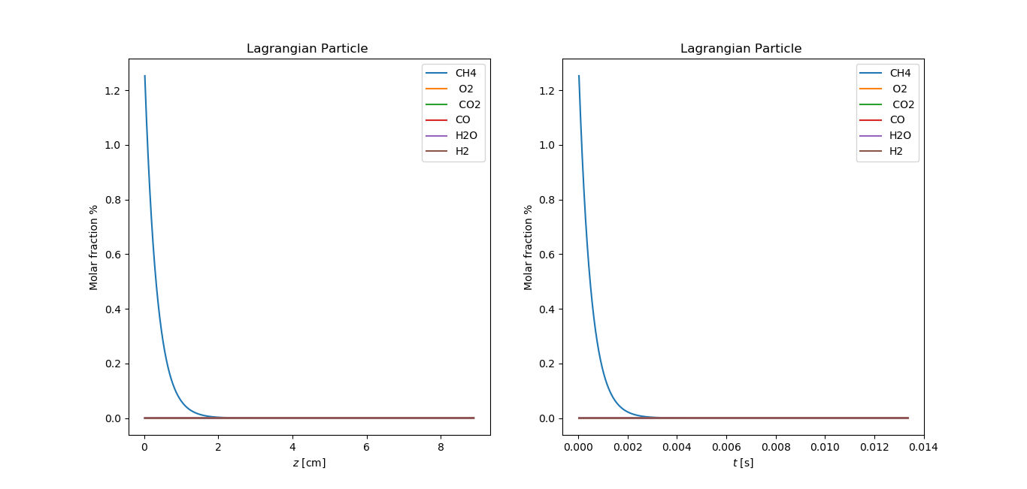

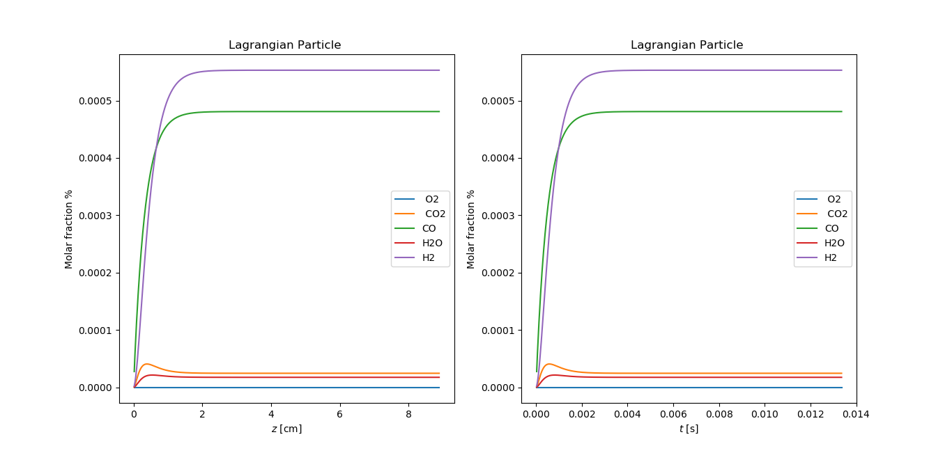

Figure The results using Lagrangian Method

*NOTE: I have no idea for this problem, I also searched more information about it on the forum, group about cantera. They almost use the chain of reactors method to simulate the surface catalytic reactor. So, I could not find a reference to check my code using Lagrangian method. That is my difficult of last week.

# 4. Conclusion

Our mechanism file includes both the phase-reaction and the surface-reaction, and our code (Chain of reactors method) has the results which fits closely with the reference.

The program using the Lagrangian method still doesn’t work, and I’m stuck in here! I keep going to find out the cause for this problem.

# References

|  |  |
| --- | --- |
| [1] | "http://puccini.che.pitt.edu/," [Online]. Available: http://puccini.che.pitt.edu/~karlj/Classes/CHE400/lecture19_web.pdf. [Accessed 3 4 2020]. |
| [2] | L. M. S. T. l. Z. H. S. O. D. Karla Herrera Delgado, "Surface Reaction Kinetics of Steam and CO2 - Reforming as well as Oxidation of Metane over Nickel-Based Catalysts.," *Catalyst,* no. 5, pp. 871-904, 2015. |

Link:

Gantt chart: <https://docs.google.com/spreadsheets/d/1pgTm9QTVgA2n_2NetLwpwnbW8kADJNP6VqgRpcv_keI/edit?usp=sharing>